SOFTWARE REQUIREMENT SPECIFICATION (SRS)
SUSTAINABLE FOOD WASTE REDUCTION PLATFORM
SDG 12: RESPONSIBLE CONSUMPTION AND PRODUCTION

CHAPTER 1-INTRODUCTION
1.1Purpose
This Software Requirement Specification (SRS) document defines the functional and non-functional requirements for a Sustainable Food Waste Reduction Platform. The platform is proposed by a nonprofit organization to connect food donors — restaurants, supermarkets, and event organizers — with registered charities, enabling the timely and safe redistribution of surplus food to vulnerable communities. This document guides the development team, project stakeholders, and evaluators through design, implementation, and validation of the system.

1.2Business Domain
The platform operates at the intersection of food-service logistics, nonprofit social welfare, and civic technology, directly supporting UN Sustainable Development Goal 12 by reducing edible food wastage and improving resource efficiency across the food supply chain.

1.3 Stakeholders
- Food Donors – restaurants, supermarkets, catering companies, event organizers with surplus food
- Charities / NGOs – registered organizations serving food-insecure communities
- Delivery Volunteers / Logistics Partners – transport food from donor to charity
- Nonprofit Platform Operator – organization owning/administering the platform
- Food Safety / Municipal Authorities – regulatory oversight of food handling and hygiene
- End Beneficiaries – indirect stakeholders who ultimately receive the food

1.4 Existing Challenges
- Surplus food is discarded because donors lack a fast channel to reach nearby charities
- Charities have no centralized way to discover available food, causing missed donations
- Manual, phone-based coordination is slow and doesn't scale for perishables
- Lack of verification creates trust and food-safety concerns
- No standardized tracking exists to measure redistribution impact for funders/regulators

1.5 System Objectives
- Provide a real-time marketplace connecting donors with verified charities
- Minimize time between food becoming surplus and safe collection
- Ensure trust/accountability through donor and charity verification
- Enable logistics coordination for pickup and delivery
- Provide measurable impact data aligned with SDG 12 reporting

CHAPTER 2-PROBLEM DESCRIPTION
Restaurants, supermarkets, and event organizers routinely generate surplus edible food at the end of service periods, during over-production, or after events, which is disposed of due to the absence of an efficient redistribution mechanism. Simultaneously, charities serving food-insecure populations struggle to source consistent, timely donations because they lack visibility into when and where surplus food becomes available. This mismatch results in preventable food wastage, unnecessary landfill and greenhouse-gas impact, and missed opportunities to support vulnerable communities. The proposed platform digitally connects donors and charities, automates discovery and claiming of surplus food, coordinates pickup/delivery logistics, and provides verification and impact-tracking capabilities.

CHAPTER 3-SCOPE OF THE SYSTEM
In scope: donor and charity registration/verification; posting, discovery, and claiming of food donation listings; pickup/delivery scheduling and optional volunteer assignment; real-time status tracking; impact reporting and analytics; administrative oversight of users and compliance. Delivered as a responsive web app plus Android/iOS apps.
Out of scope (initial release): payment processing for purchased food, direct e-commerce functionality, automated government regulatory filing.

CHAPTER 4-FUNCTIONAL REQUIREMENTS
ID | Requirement Description | Priority
FR-01 | Allow food donors (restaurants, supermarkets, event organizers) to register and create a verified donor profile | High
FR-02 | Allow charities to register and submit verification documents (registration certificate, license) for admin approval | High
FR-03 | Allow authenticated donors to post a surplus food listing including food type, quantity, preparation time, expiry window, storage requirements, and pickup location | High
FR-04 | Allow charities to browse, filter, and search listings by location, category, quantity, and pickup time window | High
FR-05 | Allow a charity to claim/request a listing, preventing double-claiming of the same listing | High
FR-06 | Notify the donor in real time when claimed, and notify nearby charities when a new listing is posted | High
FR-07 | Allow scheduling of a pickup/delivery slot and assignment of a delivery volunteer/logistics partner | High
FR-08 | Provide real-time status tracking (Posted → Claimed → Scheduled → Collected → Delivered → Closed) | Medium
FR-09 | Allow donors and charities to rate and review each completed transaction | Low
FR-10 | Generate impact reports/dashboards on food redistributed, beneficiaries served, and CO2/landfill waste avoided | Medium
FR-11 | Allow administrators to manage user accounts, verify charity credentials, and suspend non-compliant users | High
FR-12 | Send automated expiry alerts as a claimed donation's safe-consumption window approaches | Medium
FR-13 | Maintain a searchable donation history for each donor and charity | Low
FR-14 | Integrate with a maps/geolocation service to compute distance/travel time between donor and charity | Medium
FR-15 | Allow admins/food safety authorities to flag listings lacking minimum food-safety documentation | Medium

CHAPTER 5-NON-FUNCTIONAL REQUIREMENTS
ID | Category | Requirement Description | Priority
NFR-01 | Performance | Display search results within 2 seconds under normal load (up to 5,000 concurrent users) | High
NFR-02 | Scalability | Architecture supports horizontal scaling from single-city to multi-city, multi-tenant deployment | Medium
NFR-03 | Reliability/Availability | Maintain 99.5% uptime, with automated failover for notification/matching services | High
NFR-04 | Security | Encrypt data in transit (TLS 1.2+) and at rest; enforce role-based access control | High
NFR-05 | Usability | Usable by non-technical staff within 15 minutes onboarding; WCAG 2.1 AA compliant | High
NFR-06 | Maintainability | Modular, service-oriented architecture allowing independent module updates | Medium
NFR-07 | Interoperability | Expose REST APIs for third-party logistics, SMS/WhatsApp gateways, municipal databases | Medium
NFR-08 | Auditability | Maintain immutable audit logs of all donation transactions for traceability | Medium
NFR-09 | Localization | Support multiple languages and regional date/time/unit formats | Low
NFR-10 | Portability | Accessible via responsive web browsers and native Android/iOS apps | Medium

CHAPTER 6-ACTORS AND USE CASES
6.1 Primary Actors
- Food Donor – posts surplus food listings
- Charity Representative – browses and claims donations
- Delivery Volunteer – transports food from donor to charity
- System Administrator – manages users, verification, compliance
Secondary Actors
- Food Safety Authority – audits compliance-flagged listings
- Notification Gateway – external SMS/push/email service
- Maps/Geolocation Service – distance and routing data

6.2 Major Use Cases by Actor
- Food Donor: Register/Login, Post Food Donation Listing, Track Donation Status, View Donation History, Rate & Review Transaction
- Charity Representative: Register/Login, Browse Available Donations, Claim/Request Donation, Schedule Pickup, Track Donation Status, Generate Impact Reports
- Delivery Volunteer: Login, View Assigned Pickups, Update Delivery Status
- System Administrator: Verify Charity Registration, Manage Users & Access, Monitor Food Safety Compliance, Generate Platform-Wide Reports

6.3 Use Case Diagram
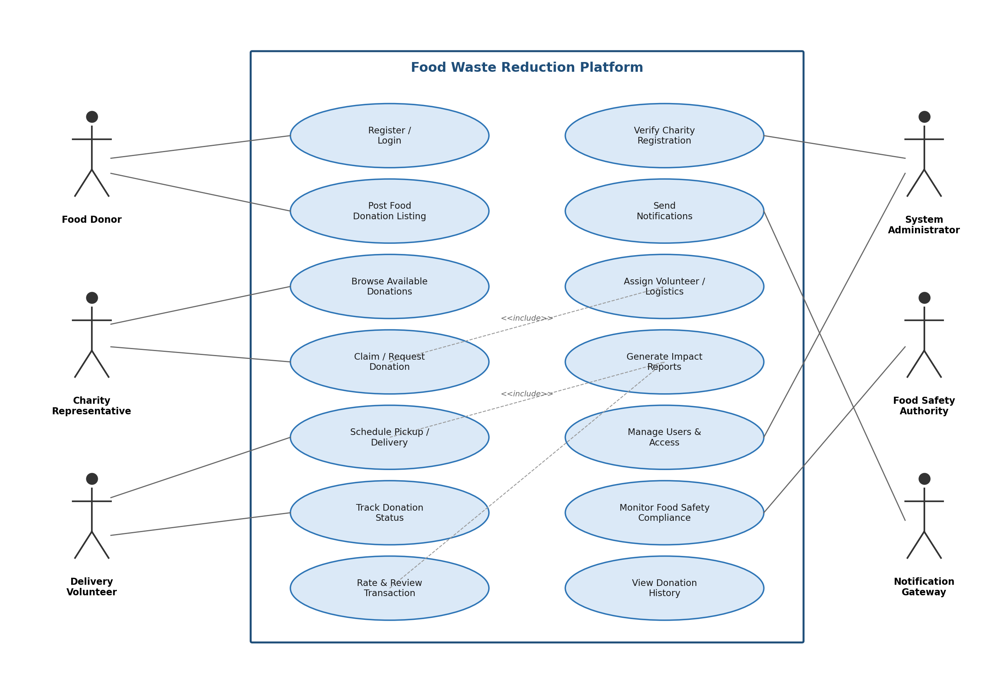

6.4 Sample Use Case Descriptions
UC-01: Register / Login
- Actors: Food Donor, Charity Representative, Delivery Volunteer, System Administrator
- Description: Allows a new user to create an account with role selection and authenticate on subsequent visits
- Preconditions: User has a valid email/phone number
- Main Flow: User selects role → enters registration details → system validates and creates account → charity accounts routed to Admin for verification → user logs in
- Alternate Flow: Invalid verification documents → registration rejected, resubmission prompted
- Postconditions: User account created and, where applicable, verified

UC-03: Browse & Claim Donation
- Actors: Charity Representative
- Description: Allows a charity to search available listings and claim one matching its need/capacity
- Preconditions: Charity is verified and logged in
- Main Flow: Charity searches/filters listings → selects and claims a listing → system locks listing → donor notified
- Alternate Flow: Listing already claimed → unavailability message shown, results refreshed
- Postconditions: Listing status changes to "Claimed"; hidden from other charities

UC-07: Verify Charity Registration
- Actors: System Administrator, Food Safety Authority
- Description: Validates that a registering charity is legitimate and compliant before granting full access
- Preconditions: Charity has submitted registration documents
- Main Flow: Admin reviews documents → approves/rejects → system updates status and notifies applicant
- Alternate Flow: Incomplete documents → admin requests additional information
- Postconditions: Charity account marked Verified or Rejected

CHAPTER 7-DATA REQUIREMENTS
- User Profile – name, role, contact, address, verification status
- Donation Listing – food type, quantity, unit, expiry timestamps, storage needs, pickup location, photos, status
- Claim/Transaction Record – listing reference, claiming charity, timestamps, assigned volunteer
- Verification Document – registration certificate, license number, verification status
- Notification Log – recipient, channel, message, delivery status
- Rating/Review – transaction reference, rating value, comments
- Impact Metrics – quantity redistributed, beneficiaries served, CO2/landfill diversion estimates
- Audit Log – actor, action, entity, timestamp

Chapter 8-External Interface Requirements
- User Interfaces: responsive web portal; native Android/iOS apps
- Hardware Interfaces: mobile camera (listing/proof-of-collection photos); GPS (volunteer tracking)
- Software Interfaces: Maps/Geolocation API; SMS/Push/Email gateway; municipal food-safety data interface
- Communication Interfaces: HTTPS/REST APIs (TLS); webhook-based event notifications

CHAPTER 9-SYSTEM FEATURES SUMMARY
- Real-time donation marketplace with location-based matching
- Verified donor/charity onboarding with document review workflow
- Automated notifications and expiry alerts
- Pickup/delivery scheduling with optional volunteer assignment
- End-to-end status tracking and transaction history
- Impact analytics dashboard aligned with SDG 12
- Administrative console for verification and compliance monitoring

CHAPTER 10-ASSUMPTIONS AND CONSTRAINTS
Assumptions
- Donors/charities have access to internet-connected devices
- Charities are legally registered and can provide documentation
- Basic storage handling at donor premises is adequate until pickup
- Volunteers/logistics partners are available in the operating region

Constraints
- Technical: Must operate within nonprofit cloud budget (favor managed/serverless services)
- Operational: Depends on timely donor postings; cannot compel donations
- Economic: Costs minimized since funded via grants, not commercial revenue
- Legal: Must comply with local food safety/liability regulations (e.g., Good Samaritan food donation laws)
- Time-related: Perishables require near-real-time processing; latency increases spoilage risk

CHAPTER 11-VALIDATION OF REQUIREMENT COMPLETENESS AND CONSISTENCY
11.1 Stakeholder Coverage Check
Every stakeholder maps to requirements: Donors (FR-01, FR-03), Charities (FR-02, FR-04, FR-05), Volunteers (FR-07), Administrators (FR-11, FR-15), indirect beneficiaries (FR-10).

11.2 Ambiguity, Redundancy, Inconsistency Review
- Ambiguity resolved: "timely"/"nearby" quantified via NFR-01 (2-second response) and FR-14 (geolocation distance)
- Redundancy checked: FR-05 and FR-08 reviewed to confirm claim-locking and status-tracking don't overlap
- Consistency: Priority levels applied uniformly by impact on core flow vs. supporting features
- Gap found & fixed: Expiry handling for unclaimed listings was missing → added FR-12 and "Expired" status in UC-05

11.3 Suggested Improvements
- Reputation/trust score for donors and charities
- Predictive analytics forecasting surplus volumes by donor type/time
- Automated compliance certification via municipal authority integration
- Offline-first mobile support for volunteers in low-connectivity areas
- Multi-charity split-claiming for large donations

